NIP Project — Submission Template
Pega Platform project · This document is your complete submission
Read this before you start:
1. Fill in Section 1 completely. The Pega application name must follow the format NIP-[Project]-[YourName].
2. Create a new Operator in Pega with your full name and log in as that operator before taking any screenshot.
3. When you create your test case, enter YOUR FULL NAME in the Issue Description (Vehicle) or Movie Name (Movie) field.
4. Complete only the section for your chosen project. Delete the other project section.
5. Paste one screenshot per user story (10 total). Follow the screenshot rules in your selected project section.
6. Answer every question in Sections 3 and 4 in your own words.
7. Save the file using this format: ProjectName_FirstName_LastName.docx. Use VehicleService or MovieTicket as the ProjectName. Examples: VehicleService_Ravi_Kumar.docx or MovieTicket_Ravi_Kumar.docx.

Section 1 — Your Details
Full Name | Manojrajivee B
Email ID (registered on NIP) | manojrajiveeoff12@gmail.com
Phone Number | 9344385330
College Name | V.S.B.Engineering College,KARUR.
Course (e.g. IT, CS) | CSE
State | TAMILNADU
Project Chosen (Vehicle Service OR Movie Ticket Booking) | Movie Ticket Booking
Pega Application Name (e.g. NIP-VehicleService-YourName) | NIP-MovieTicket-ManojRajivee
Case Type Name (exact) | Movie Ticket Request
Pega Instance URL | https://tbmmvu1w.pegaacademy.net/prweb/app/ticketing-and-booking/CtYds566Y7g0wqmzQXJaidwV3WuwKfQA*/!STANDARD?pzuiactionzzz=CXtycX0wNjZjYzJlMGZhYjJmZDlhN2MzZWEwOGI4NjViOTgzMDk0Y2E0M2Y1MDg1NjMxOGNhZTlmYmIzNTg1MzRiZWY5NTYxOTU4ZjAxNGZkMTQzN2IwOTY3NjViMGU5MTU4N2Q=*
Operator Name (created in Pega with your full name) | author@uplus

Section 2B — Movie Ticket Booking Management Application
Complete this section only if you selected this project. Delete the other project section before submitting.

Screenshot rules — IMPORTANT before you start:
1. Name your Pega application as: NIP-VehicleService-YourName OR NIP-MovieTicket-YourName
2. Create a new Operator in Pega with your full name (Security → Operators) and log in as that operator.
3. When you create your test case, enter YOUR FULL NAME in the Issue Description (Vehicle) or Movie Name (Movie) field.
4. The logged-in operator name must be visible in every screenshot wherever the Pega interface displays it.
5. The student's full name must be visible in all running-case screenshots.
6. Configuration screenshots must clearly show the relevant application or rule name.
Screenshots that do not show these will not be accepted.

US-001 — Submit Movie Ticket Request
What is expected:
Case created, customer submits Movie Name, Show Date, Show Time, Number of Tickets. Validation applied.
Screenshot — paste your screenshot below this line:
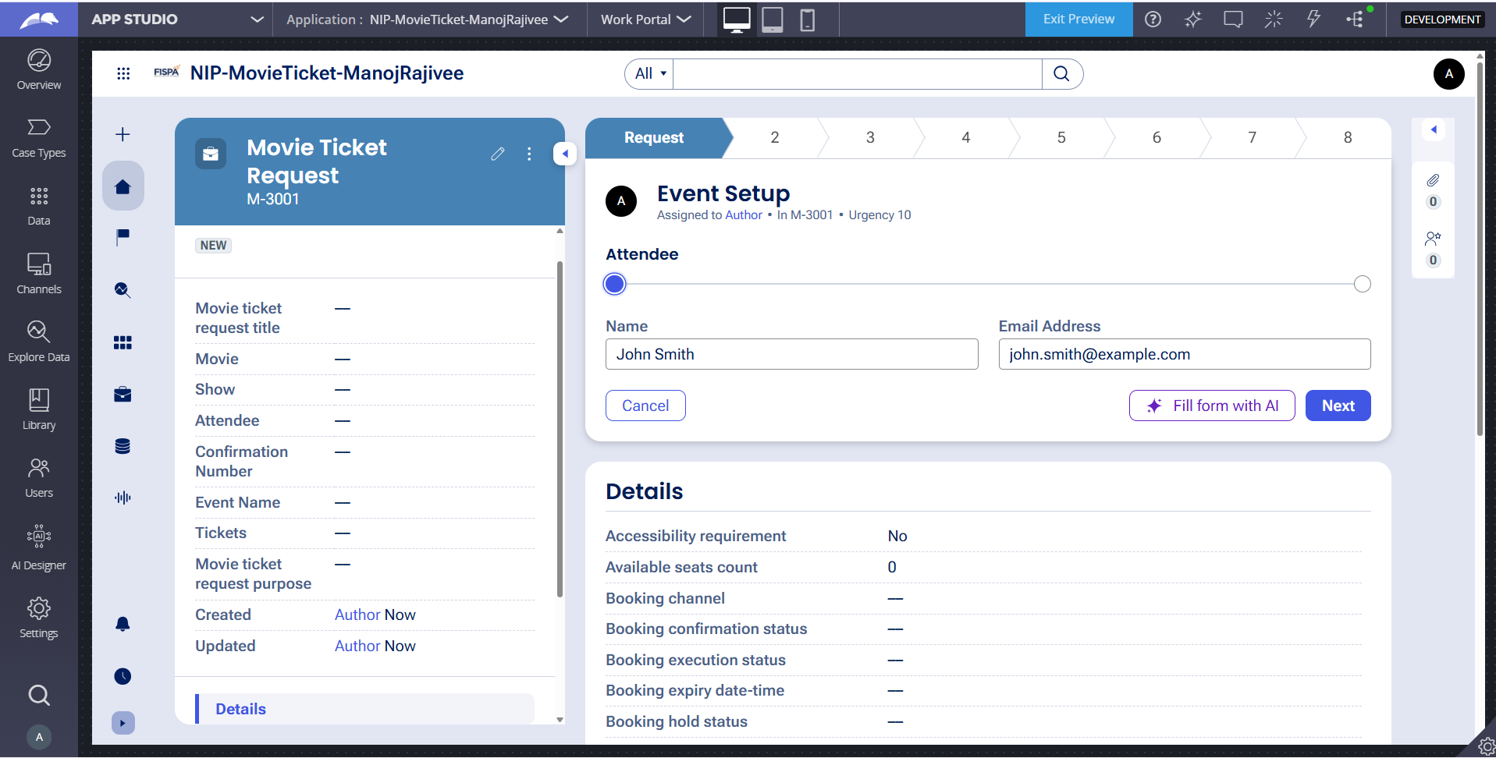

What I built for this (1–2 lines in your own words):
I created a movie ticket request form to enter the movie, show details, and number of tickets.

US-002 — Check Show Availability
What is expected:
Availability stage. Seat Availability Status and Available Seats Count captured. Booking proceeds only if available.
Screenshot — paste your screenshot below this line:
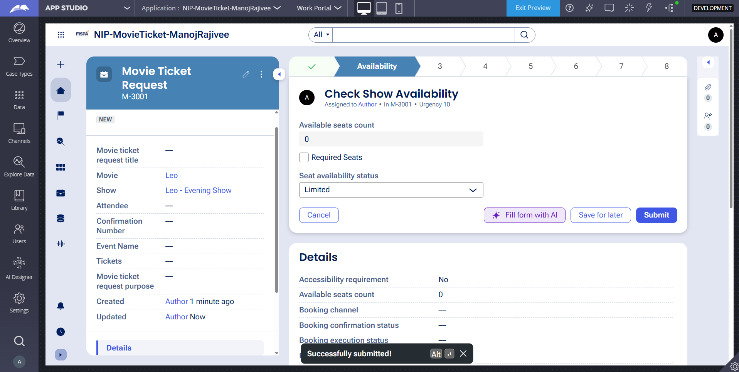

What I built for this (1–2 lines in your own words):
I added show availability checking to confirm whether enough seats are available.

US-003 — Calculate Booking Cost
What is expected:
Total Cost calculated automatically from Ticket Price and Number of Tickets using a business rule.
Screenshot — paste your screenshot below this line:
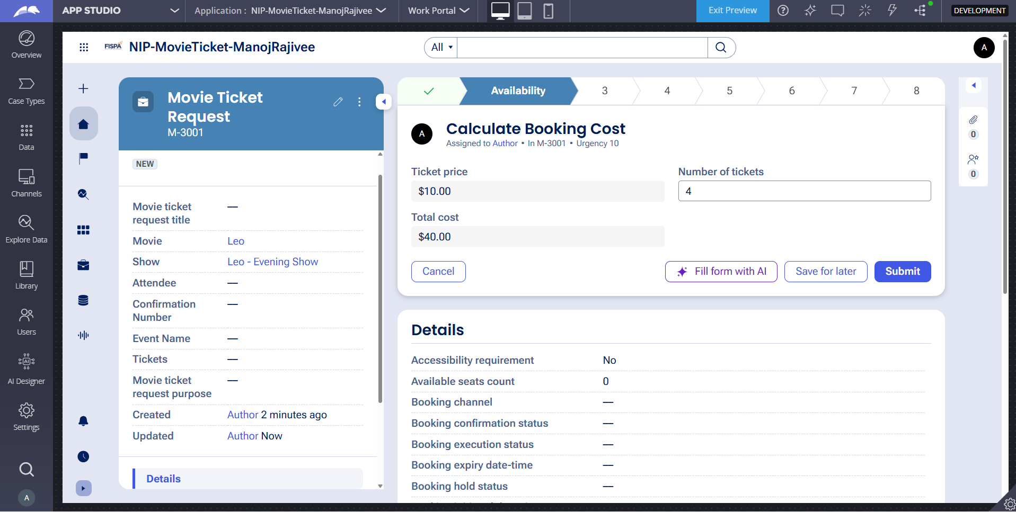

What I built for this (1–2 lines in your own words):
I created a rule that automatically calculates the total booking cost based on ticket price and quantity.

US-004 — Confirm Booking Request
What is expected:
Approval stage assigned to Customer. Booking Status captured. Flow branches on confirm/cancel.
Screenshot — paste your screenshot below this line:
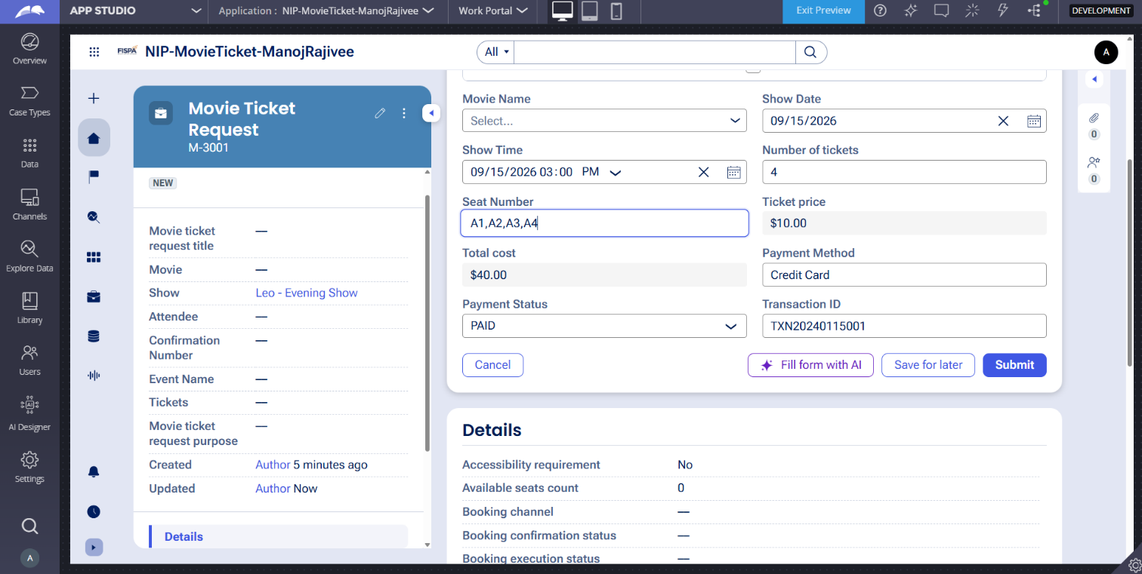

What I built for this (1–2 lines in your own words):
I added a confirmation step where the booking can be approved or cancelled.

US-005 — Maintain Movie and Show Data
What is expected:
Reusable Movie and Show data objects created with Movie Name, Genre, Show Date, Show Time, Seat Capacity — linked to case.
Screenshot — paste your screenshot below this line:
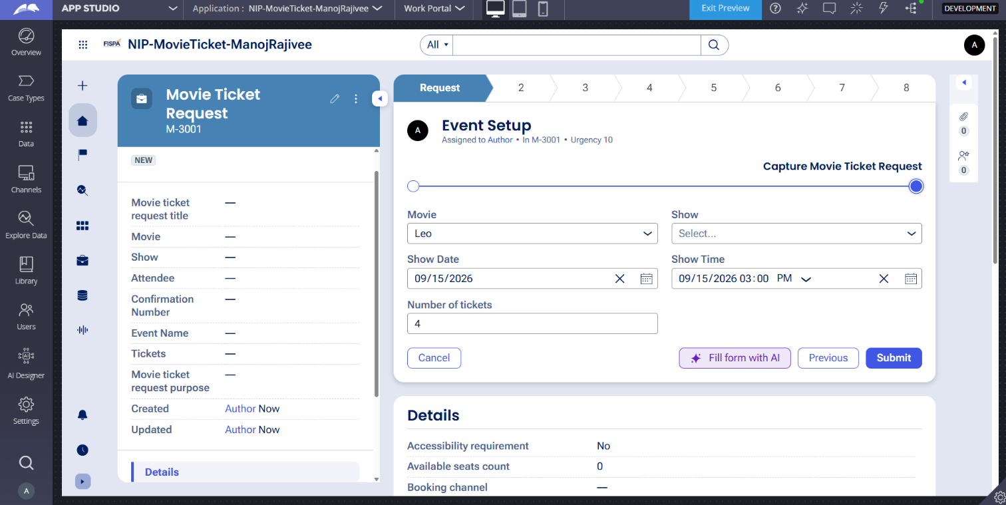

What I built for this (1–2 lines in your own words):
I created movie and show data with details like movie name, genre, date, time, and seat capacity.

US-006 — Review Booking Details
What is expected:
Confirmation screen shows Movie Name, Show Timing, Number of Tickets and Total Cost clearly.
Screenshot — paste your screenshot below this line:
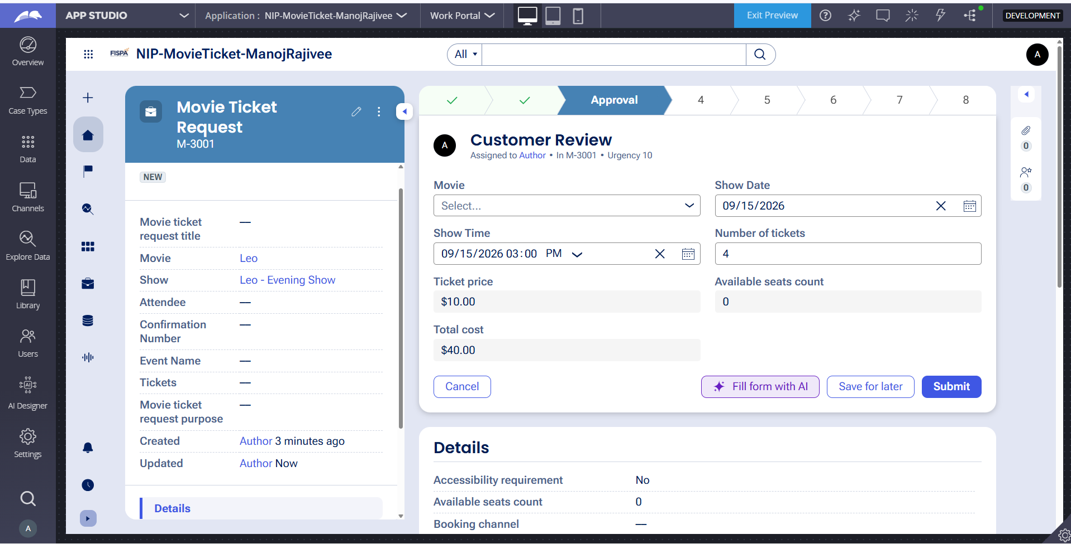

What I built for this (1–2 lines in your own words):
I added a review screen to clearly display the selected movie, show timing, tickets, and total cost.

US-007 — Process Ticket Booking
What is expected:
Booking Execution stage. Seat Numbers, Ticket ID and Booking Confirmation Status maintained.
Screenshot — paste your screenshot below this line:


What I built for this (1–2 lines in your own words):
I created the booking process to maintain seat numbers, ticket ID, and booking confirmation status.

US-008 — Notify Booking Confirmation
What is expected:
Correspondence rule triggered on case resolution. Email includes movie, show, seat and cost details.
Screenshot — paste your screenshot below this line:
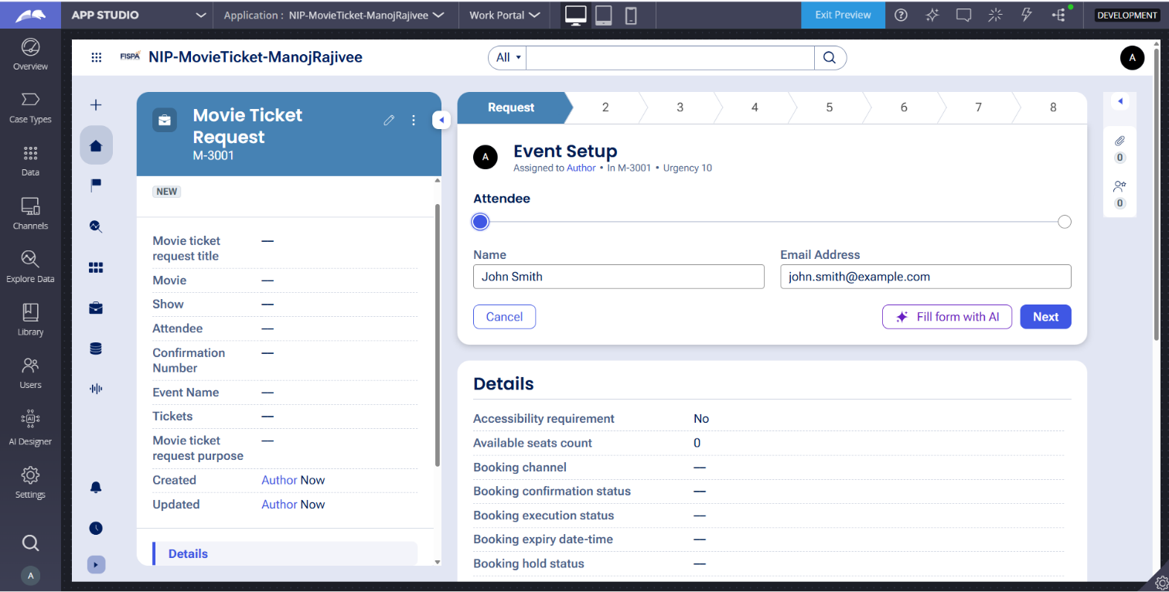

What I built for this (1–2 lines in your own words):
I added an email notification to send the booking confirmation with movie, seat, and cost details.

US-009 — Define Booking SLA
What is expected:
SLA configured on the case type. Goal: 1 day. Deadline: 2 days. Priority increases on breach.
Screenshot — paste your screenshot below this line:
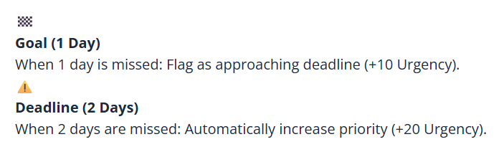

What I built for this (1–2 lines in your own words):
I configured an SLA to track the booking request deadline and increase priority if it is delayed.

US-010 — Route by Show Type
What is expected:
Routing rule or Decision Table routes to PremiumShowQueue or StandardShowQueue based on Show Type property.
Screenshot — paste your screenshot below this line:
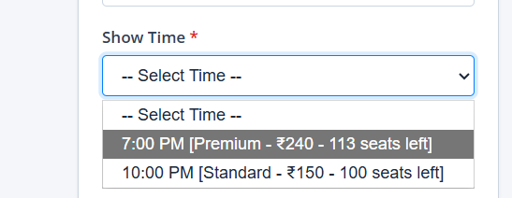

What I built for this (1–2 lines in your own words):
I created a routing rule that sends premium shows to the PremiumShowQueue and standard shows to the StandardShowQueue based on the show type.

Section 3 — About Your Application
These answers are checked against your screenshots. Write exactly what is in your application.

Q1. List your stages in the order they appear in your case lifecycle.
Stage names in order, separated by commas.
Request, Availability, Approval, Payment, Allocate Seats, Generate Ticket ID, Booking Confirmation, Customer Notification

Q2. Name the data object(s) you created and the properties inside them.
Data object name and its properties.
Data Object 1: Movie
Properties: MovieName, Genre, Language, Duration, Rating
Data Object 2: Show
Properties: ShowID, MovieReference, TheaterLocation, ShowTime, TicketPrice, AvailableSeats

Q3. What is the exact name and type of the rule you used to calculate Total Cost?
Provide:
• Rule Name
• Rule Type
• Properties used in the calculation
• Formula used
• Rule Name: CalculateBookingCost
• Rule Type: Declare Expression
• Properties used in the calculation: TicketPrice, NumberOfTickets
• Formula used: TicketPrice * NumberOfTickets

Section 4 — Your Understanding
Short, honest and specific answers score well.

Q4. What did Blueprint generate for you, and what did you add or change yourself afterwards?
Be specific about what was already there and what you built or modified on top.
Blueprint generated the initial foundational structure, including basic stage outlines, generic UI views for submitting booking requests, and initial data models. Afterward, I customized and built upon it manually by expanding the case lifecycle into 8 distinct stages, configuring advanced data relationships between Movies and Shows, adding cascading dropdown logic for theater and showtime selections, and writing custom declare expressions for booking calculations.

Q5. Was there anything Blueprint created that you had to correct or configure further? Describe one example.
A real example from your own work.
Yes. Blueprint created default placeholder data fields for show scheduling that lacked proper data reference relationships. For instance, the Show selection field was initially generated as a standard text input instead of a data reference pointing to the Show data object. I had to correct this by redefining it as a data reference with filters to ensure users could dynamically choose valid showtimes based on the selected movie.

Q6. Explain your case flow from creation to resolution, in order.
What happens first, who does what, when the case closes.
Request Stage: The customer initiates the case by submitting attendee details and movie ticket request information.
Availability Stage: The system checks show availability and calculates the booking cost.
Approval Stage: A customer review is performed to ensure all booking parameters are valid.
Payment Stage: The user completes the payment transaction.
Allocate Seats Stage: Specific seats are assigned for the movie screening.
Generate Ticket ID Stage: A unique ticket ID is generated for the reservation.
Booking Confirmation Stage: User actions finalize the booking confirmation view.
Customer Notification Stage: An automated notification is sent out to the customer, and the case successfully resolves and closes.

Q7. Pick two design choices you made in your application and explain why you made them.
For each design choice, provide:
• What you implemented
• Why you chose that approach
• What benefit it provides to the application
Design Choice 1: Implementing data references for Movies and Shows instead of hardcoding text fields.
• What you implemented: Configured structured data objects for Movies and Shows with data reference fields.
• Why you chose that approach: It prevents data redundancy and ensures real-time accuracy for seat availability and ticket pricing.
• What benefit it provides to the application: It allows seamless updates to showtimes and prices without modifying the core case type logic.
Design Choice 2: Expanding the case lifecycle into multiple granular stages (Request through Customer Notification).
• What you implemented: Added explicit stages for payment, seat allocation, ticket generation, confirmation, and notification.
• Why you chose that approach: To cleanly separate every phase of the e-commerce transaction workflow for better tracking and maintenance.
• What benefit it provides to the application: It improves operational transparency and ensures automated processes execute sequentially without errors.

Q8. What was the hardest part, and how exactly did you fix it?
Specific and honest. A real challenge scores much better than a generic answer.
The hardest part was configuring the cascading relationship between the Movie selection and the corresponding Show dropdown so that only valid showtimes appeared. Initially, selecting a movie did not properly filter the available show records. I fixed this by defining proper data page parameters, configuring report definitions with appropriate filter criteria, and mapping the filter condition correctly in the field properties configuration within App Studio.

Q9. If the approval step was only needed when Total Cost is above a certain amount, what would you change in your application?
Explain what you would change and where. You do not need to build this.
I would add a decision condition (such as a when condition rule or a decision shape) on the transition path leading into the Approval stage. The condition would evaluate whether TotalCost > [SpecifiedAmount]. If true, the flow would route into the Approval stage; if false, it would bypass the approval stage entirely and proceed directly to payment processing and seat allocation.

Q10. List three exact rule names from your application that you personally created or modified.
Include the rule name and rule type for each one (for example: CalculateTotalCost - Declare Expression).
CalculateBookingCost - Declare Expression
CustomerReview - User Action View
Send notification - Email/Notification Rule
Q11. List all personas used in your application.
List the persona names exactly as they appear in your application.
Business Architect, Customer, Booking Agent
Q12. List all work queues used in your application and explain when each one is used.
For each work queue, provide its exact name and the condition or type of work routed to it.
• StandardShowQueue: Used for routing routine ticket booking requests and standard movie screenings requiring standard operational review.
• PremiumShowQueue: Used when requests involve premium seating, VIP packages, or high-cost transactions that require specialized agent review and approval.

Before You Submit — Check These
Read through once before uploading.
1. Section 1 filled in. Application named as NIP-[Project]-[YourName]. Names match the actual application.
2. New Operator created in Pega with my full name. I logged in as that operator for all screenshots.
3. Only my chosen project section remains — the other project section is deleted.
4. All 10 user story screenshots are pasted and follow the operator, running-case, application, and rule-name evidence requirements.
5. Every question in Sections 3 and 4, including Q10, Q11, and Q12, is answered in my own words.
6. This file is named using the required format: ProjectName_FirstName_LastName.docx (for example, VehicleService_Ravi_Kumar.docx or MovieTicket_Ravi_Kumar.docx) and uploaded as required.

